**Tailor**

Tailor is a desktop application to design websites using GUI tools without writing a single line of code.

This will help designers who are not familiar with HTML, JavaScript and CSS.

Almost every websites’ elements such as buttons, menus, progress bars, icons….etc. will be available for users with only drag and drop

**Application Walkthrough:**

First screen is (splash screen):

Welcome screen with application logo and slogan.



Figure 1

Second screen is a main navigation for the application where the user can choose to view the course materials or to build the site

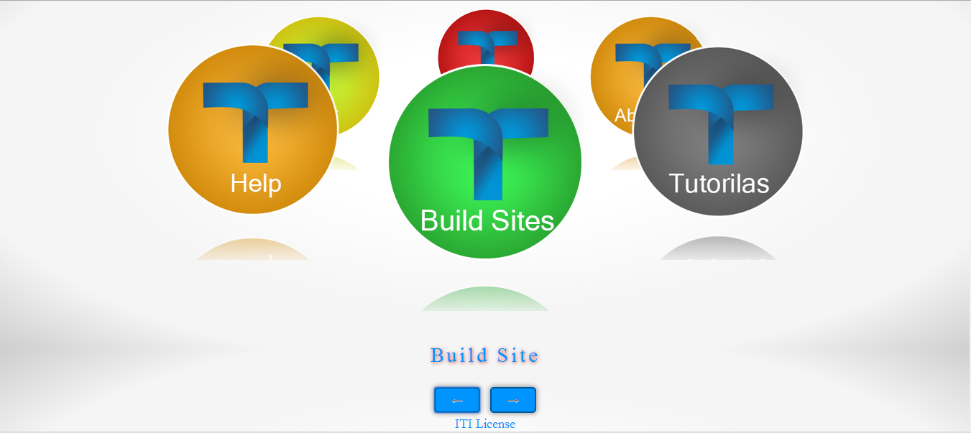Figure 2

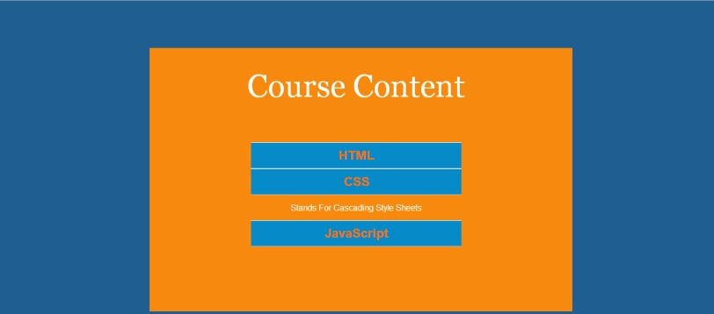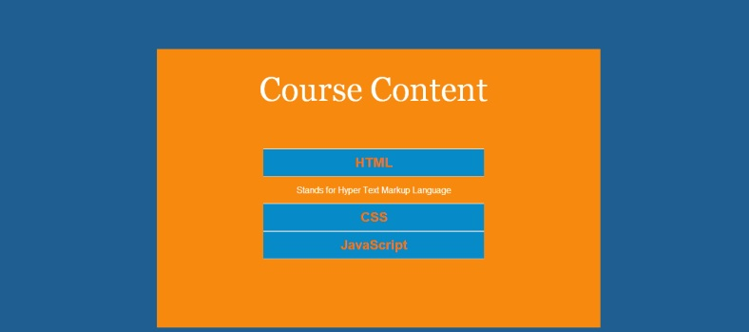If the user chooses to view the materials this screen will appear and he can choose which course to view

Figure 3 – courses

Then the main screen which contains the tools

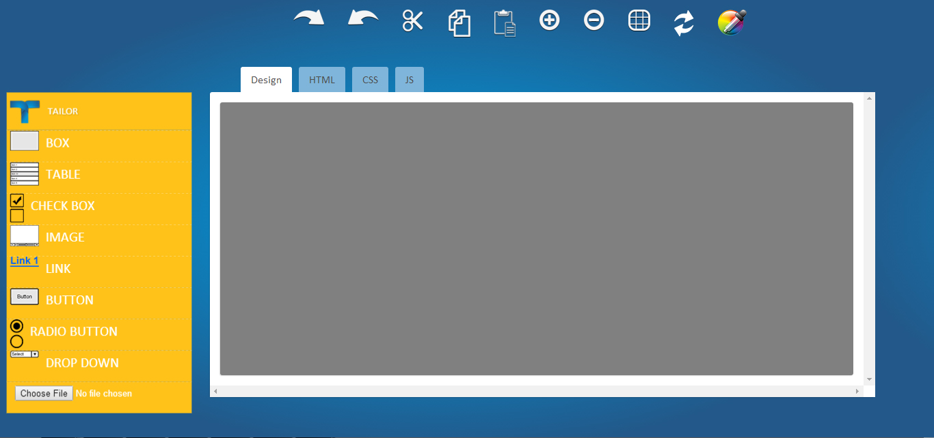Figure 4 – main screen

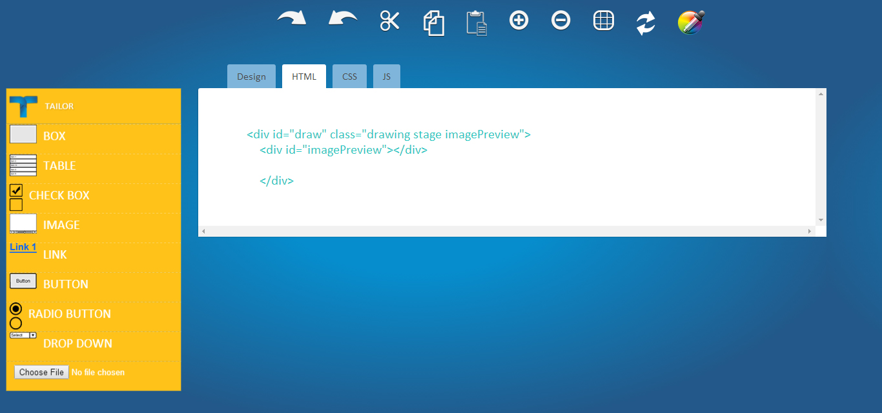The HTML tab shows the html code behind the design, CSS tab shows the style and JS tab will show the function and the animation (future work)

Figure 5 – tabs

Toolbox:

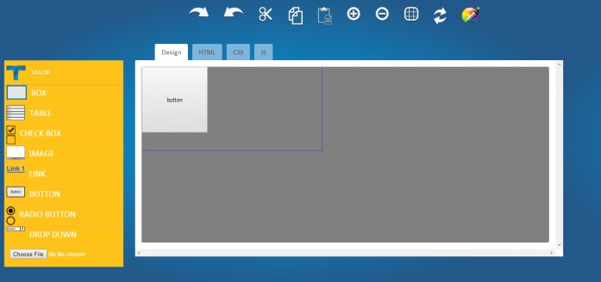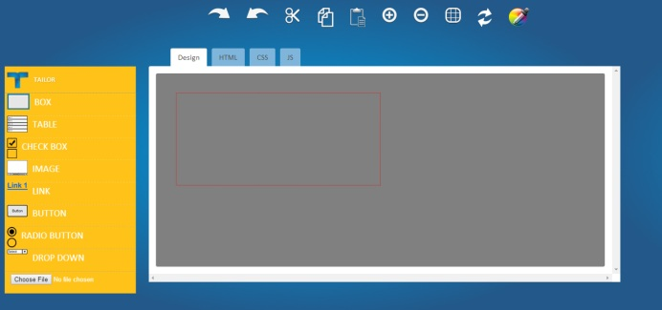1- “Box” tool which draws an empty div, the user can also insert any element in this div

Figure 6 – Box tool

2- “Table” tool it will open a popup so the user can customize the table (number of rows, number of columns, cells width and cells height in pixels)

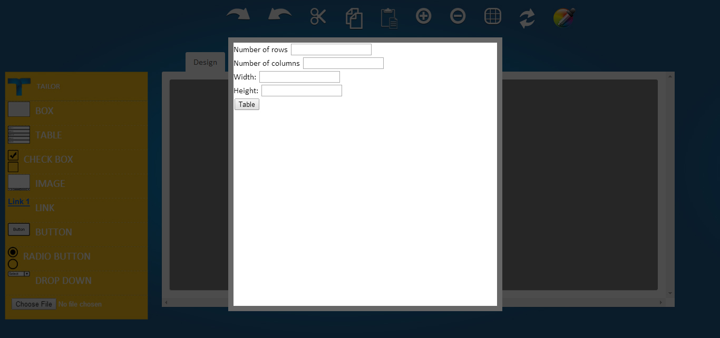

Figure 7 – table tool

3- “Image” tool will open a dialog box to insert the image in the workspace

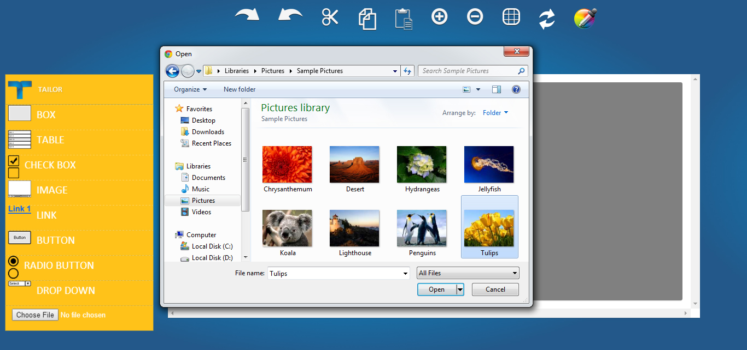

Figure 8 – image tool

4 - “Button” tool will show a popup that allow the user to insert the button-text, the width and the height in pixels

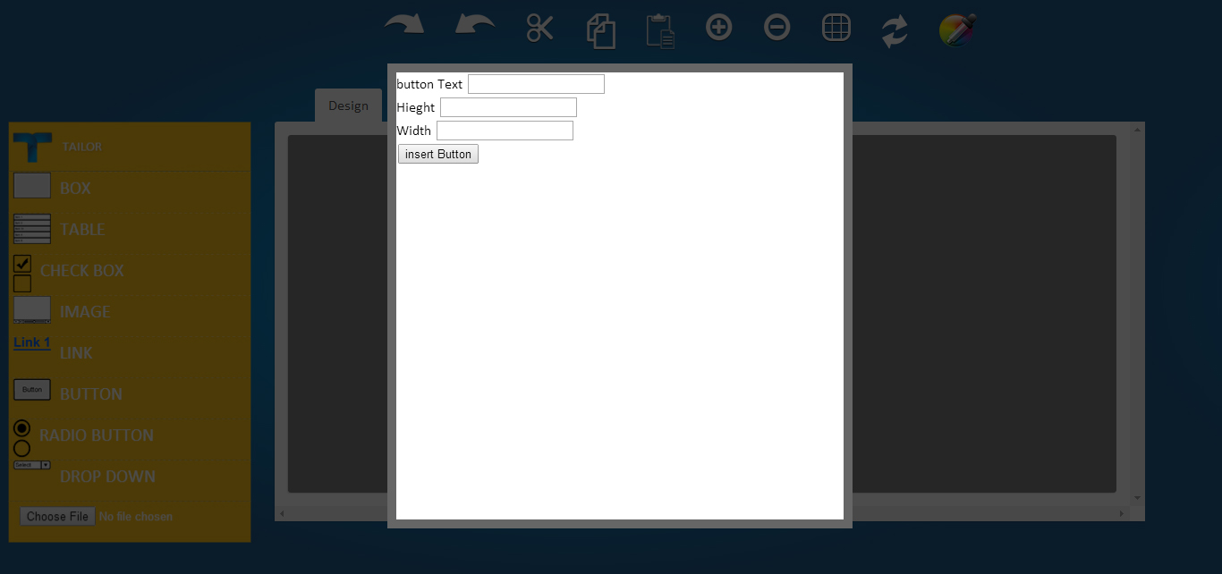

Figure 9 – button tool

5- “Radio button” tool will insert a group of radio buttons and by clicking on “finish” button the element will appear on the workspace

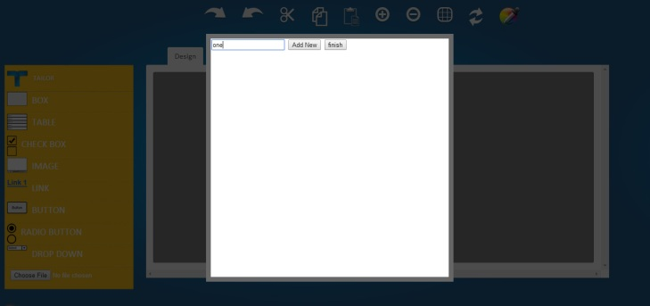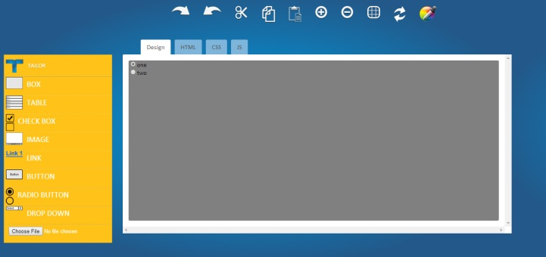

Figure 10 – radio button tool

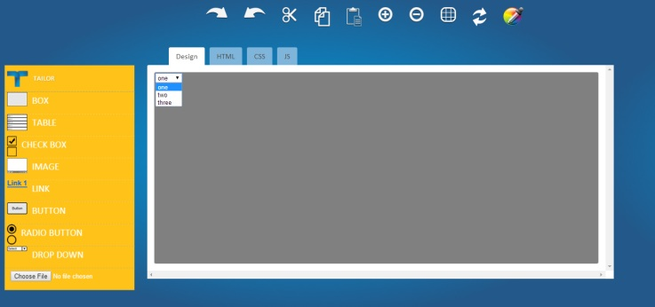6 - “Drop down” shows a popup to insert the values of the dropdown menu. By clicking finish a drop down menu appears on the workspace.

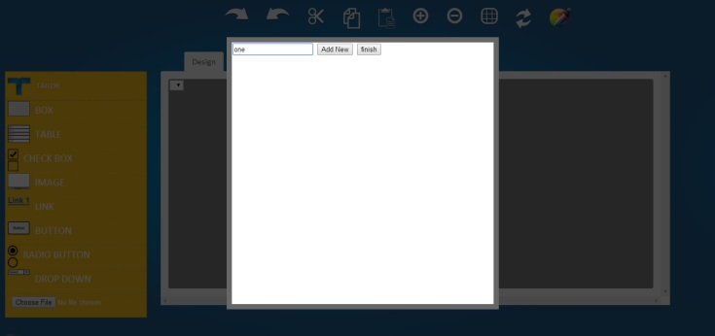Figure 11 – drop down tool